Check Out Our Classroom Website!!!
The class website includes:
-Pictures
-Continent and Ocean Review Games
-Addition, Subtraction, Multiplication, and Division Games
-Grammar and Language Arts practice activities
-Extra practice for the many topics we will cover in the Bridges Math Program
-Spelling activities
-Newsletters
-Study Guides for upcoming tests
dcastonguay.weebly.com

Upcoming Dates
Oct. 4 Picture Day/Count Day
Oct. 19 ½ Day (Elementary Only)

Behavior Sheets
Behavior sheets are in your child’s Friday Folder. Please make sure to check your child’s behavior for the week, sign the sheet, and have your child return it to school on Monday morning. Thank you for your support!

Volunteer Background Check Code

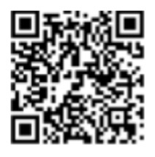
If you would like to volunteer for class parties, field trips, etc., please scan this QR code to fill out the Google form.
