Harvest Fest/Fun Run
What an amazing turn out Hollywood had for the Harvest Fest/Fun Run. Our school raised over $20,000! Thank you for your support through the fundraiser and attending the awesome event…It was a blast!
Vocabulary A-Z
Vocabulary A-Z is a great tool to practice word work with your child. To login to Vocabulary A-Z please go to https://www.kidsa-z.com/main/Login.
Search for my username: dcastonguay18
User (It’s a little circle)
Cubs
Password
Test
Upcoming Dates
Oct. 19 ½ Day (Elementary Only)
Oct. 27 ½ Day (End of Quarter)

Behavior Sheets
Behavior sheets are in your child’s Friday Folder. Please make sure to check your child’s behavior for the week, sign the sheet, and have your child return it to school on Monday morning. Thank you for your support!

Picture Day:
Picture day is Wednesday, October 4. To place and order please go to the following link: https://inter-state.com/FlyerEntry
Order Code: 81394FF
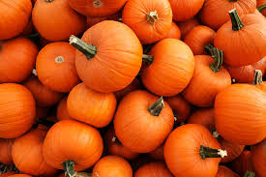
Happy Fall

